1.Python program which accepts the user's 1st and last name and print them in reverse order with space.

a=str(input("Enter your first name"))

b=str(input("Enter your last name"))

print(b,a)

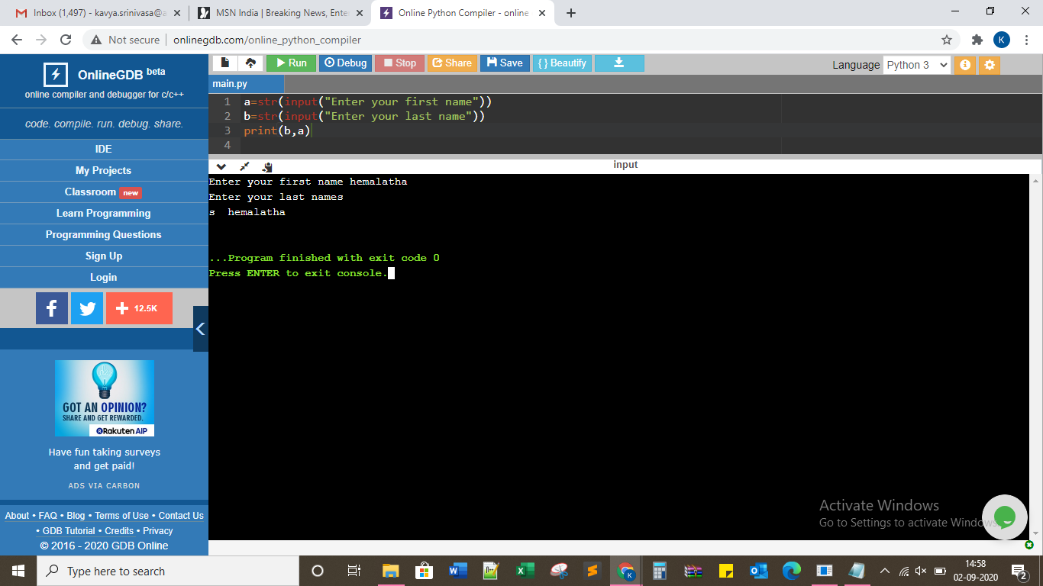

2.Python program to find number of days between two given dates.

from datetime import date

f_date = date(2014, 7, 2)

l_date = date(2016, 7, 11)

delta = l_date - f_date

print(delta.days)

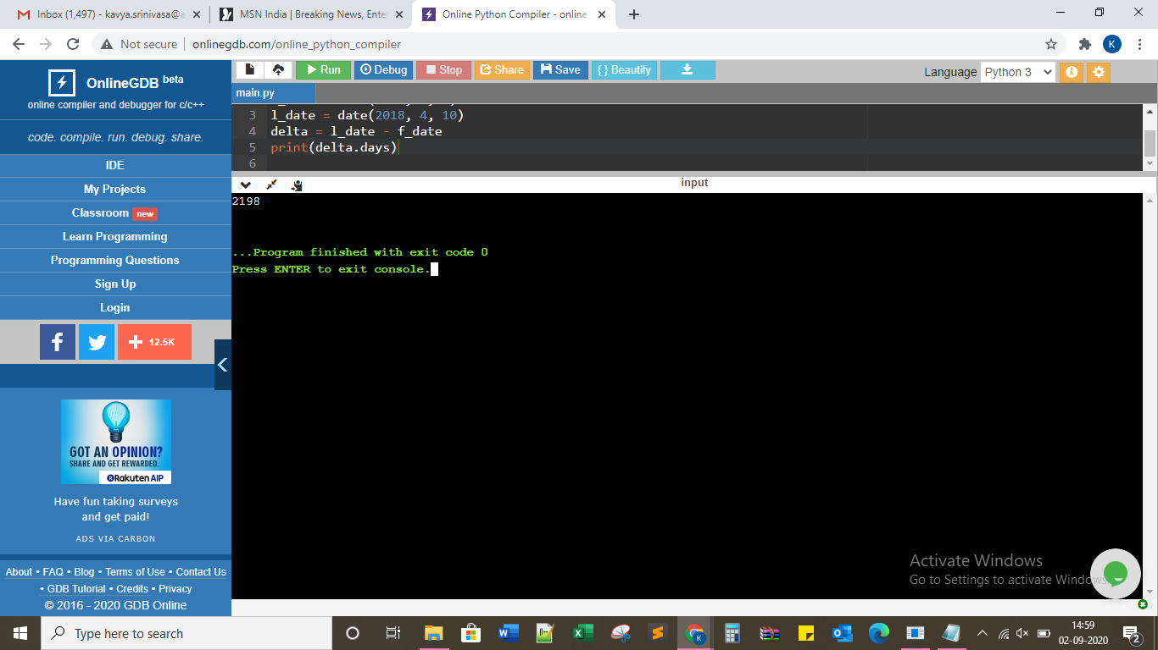

3.Python program to test whether the passed letter is vowel.

a=str(input("Enter the letter"))

if a in ['a','e','i','o','u','A','E','I','O','U']:

print("Yes",a,"is a vowel")

else:

print("No",a,"is not a vowel")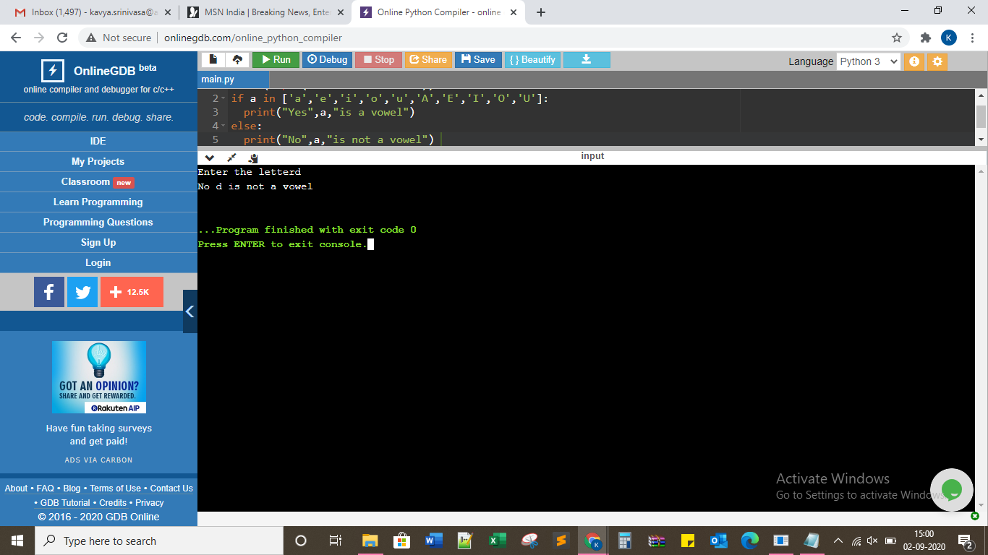

4.Python program to sum three given integers.if two values are equal sum will be 0.

a=int(input("Enter the 1st number"))

b=int(input("Enter the 2nd number"))

c=int(input("Enter the 3rd number"))

if (a==b or a==c or b==c):

print("The sum is 0")

else:

print("The sum is",a+b+c)

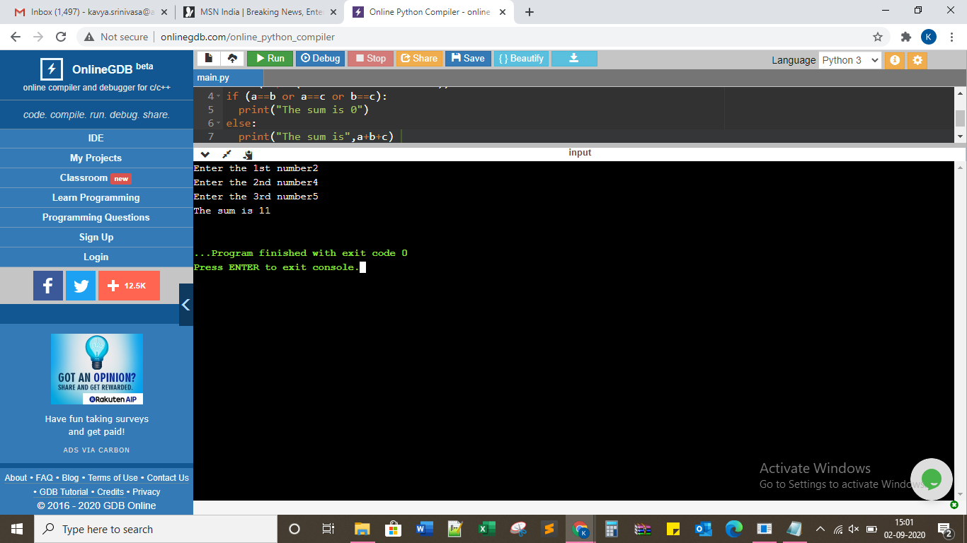

#Python program to count number of characters in a string.

a = input("Enter the string :")

f = {}

for i in a:

if i in f:

f[i] += 1

else:

f[i] = 1

print ("Count of all characters is :\n "+str(f))

